SDS ON
ITEM, VENDOR AND CUSTOMER
MAINTENANCE FILES

Introduction

Purpose: The purpose of my case study is to develop an enterprise system that manages and maintains three maintenance master files: Item, Customer and Vendor. This system will store, organize, and update essential information about products, customers and suppliers. It aims to improve data accuracy and streamline business operations by ensuring that all relevant information is easily accessible and well-maintained. This system will enhance communication and efficiency, supporting better decision-making and smoother workflows in the organization.
These master files serve as the foundation for various organizational functions:
- Item Master File: This file contains product related information, including item number, unit pricing, inventory levels, and other attributes critical for inventory management and order processing.

- Customer Master File: This File contains details about customers, including name, address, contact information, credit limit, and other attributes.

- Vendor Master File: This file contains details about vendors, including name, address, contact information, credit limit, and other attributes.
Scope of Project
The scope of my project includes the development and implementation of a comprehensive Master Data Management System for handling the Customer Master File, Vendor Master File, and Item Master File on the AS400 platform.

Overview
Master database files forms the backbone of any organization’s operation, acting as a central repository for important business information. This project focuses on the design and information of a Master Data management for maintaining and managing the Customer Master file, Vendor master file, and Item Master file on the AS400.
Key features of the project include the ability to perform CRUD operations (Create, Read, Update, Delete) on the master files, enforce data validation rules, and interconnect these master files to enhance workflows such as order processing, inventory tracking, and vendor management.
This Project highlights the strategic importance of structured and well-maintained master data in improving operational efficiency and supporting business growth. By providing a solid Framework for managing master data, this initiative empowers organizations to streamline their processes and maintain a competitive edge in the industry.

Development Tools
This section is an account of technologies that could be used in the development of the system.
Front End Technology
RPG
RPG syntax in free form is like other modern languages and can be understood easily. It allows programmers who are familiar with other languages such as Microsoft Visual Basic, Java, and PHP to be trained more easily in RPG and with lower cost. The new syntax also makes programming easier for existing RPG programmers. As such, the free-form syntax is beneficial for both existing RPG programmers and new RPG programmers.

Backend Technology
DB2
DB2 is an organized collection of data. DB2 exploits the file system, it uses different kinds of tablespaces to extract the data as fast as it can from the physical device.
The language that we use to access the data in Db2 tables is the structured query language (SQL). SQL is a standardized language for defining and manipulating data in a relational database.

ER Diagram
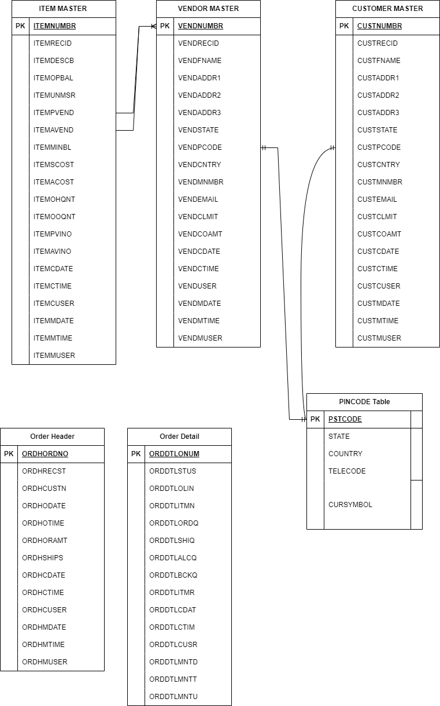
Data Directory
Customer Master PF (CUSTMASTER)
S.NO | FIELD NAME | TYPE | SIZE | DESCRIPTION
1 | CUSTRECID | A | 2 | Record Id (AC/ZC)
2 | CUSTNUMBR | S | 6,0 | Customer Number
3 | CUSTFNAME | A | 30 | Customer Name
4 | CUSTADDR1 | A | 30 | Address Line 1
5 | CUSTADDR2 | A | 30 | Address Line 2
6 | CUSTADDR3 | A | 30 | Address Line 3
7 | CUSTSTATE | A | 30 | State
8 | CUSTPCODE | A | 6 | Postal Code
9 | CUSTCNTRY | A | 20 | Country
10 | CUSTMNMBR | A | 20 | Telephone Number
11 | CUSTEMAIL | A | 70 | Email
12 | CUSTCLMIT | S | 15,2 | Credit Limit
13 | CUSTCOAMT | S | 15,2 | Current O/s Amount
14 | CUSTCDATE | S | 8,0 | Creation Date
15 | CUSTCTIME | S | 6,0 | Creation Time
16 | CUSTCUSER | A | 10 | Created By User
17 | CUSTMDATE | S | 8,0 | Maintenance Date
18 | CUSTMTIME | S | 6,0 | Maintenance Time
19 | CUSTMUSER | A | 10 | Maintenance By User

Vendor Master PF (VENDMASTER)
S.NO | FIELD NAME | TYPE | SIZE | DESCRIPTION
1 | VENDRECID | A | 2 | Record Id (AC/ZC)
2 | VENDNUMBR | S | 6,0 | Customer Number
3 | VENDFNAME | A | 30 | Customer Name
4 | VENDADDR1 | A | 30 | Address Line 1
5 | VENDADDR2 | A | 30 | Address Line 2
6 | VENDADDR3 | A | 30 | Address Line 3
7 | VENDSTATE | A | 30 | State
8 | VENDPCODE | A | 6 | Postal Code
9 | VENDCNTRY | A | 20 | Country
10 | VENDMNMBR | A | 20 | Telephone Number
11 | VENDEMAIL | A | 70 | Email
12 | VENDCLMIT | S | 15,2 | Credit Limit
13 | VENDCOAMT | S | 15,2 | Current O/s Amount
14 | VENDCDATE | S | 8,0 | Creation Date
15 | VENDCTIME | S | 6,0 | Creation Time
16 | VENDCUSER | A | 10 | Created By User
17 | VENDMDATE | S | 8,0 | Maintenance Date
18 | VENDMTIME | S | 6,0 | Maintenance Time
19 | VENDMUSER | A | 10 | Maintenance By User

Item Master PF (ITEMMASTER)
S.NO | FIELD NAME | TYPE | SIZE | DESCRIPTION
1 | ITEMRECID | A | 2 | Record Id (AI/ZI)
2 | ITEMNUMBR | A | 15 | Item Number
3 | ITEMDESCB | A | 50 | Item Description
4 | ITEMOPBAL | S | 11,0 | Opening Balance
5 | ITEMUNMSR | A | 6 | Unit of Measure
6 | ITEMPVEND | S | 6,0 | Primary Vendor
7 | ITENAVEND | S | 6,0 | Alternate Vendor
8 | ITEMMINBL | S | 11,0 | Minimum Balance
9 | ITEMSCOST | S | 13,2 | Standard Cost per Unit
10 | ITEMACOST | S | 13,2 | Actual Cost per Unit
11 | ITEMOHQNT | S | 11,0 | On Hand Quantity
12 | ITEMOOQNT | S | 11,0 | On Order Quantity
13 | ITEMPVINO | A | 30 | Primary Vendor Item Number
14 | ITEMAVINO | A | 30 | Alternate Vendor Item Number
15 | ITEMCDATE | S | 8,0 | Creation Date
16 | ITEMCTIME | S | 8,0 | Creation Time
17 | ITEMCUSER | A | 10 | Created by User
18 | ITEMMDATE | S | 8,0 | Maintenance Date
19 | ITEMMTIME | S | 6,0 | Maintenance Time
20 | ITEMMUSER | A | 10 | Maintenance By User

Order Header File (ORDHEADER)
S.NO | FIELD NAME | TYPE | SIZE | DESCRIPTION
1 | ORDHRECST | A | 2 | Record Status
2 | ORDHORDNO | S | 7,0 | Order Number
3 | ORDHCUSTN | S | 6,0 | Customer Number
4 | ORDHODATE | S | 8,0 | Order Date
5 | ORDHOTIME | S | 6,0 | Order Time
6 | ORDHORAMT | S | 15,2 | Order Amount
7 | ORDHSHIPS | A | 4 | Shipment Status
8 | ORDHCDATE | S | 8,0 | Creation Date
9 | ORDHCTIME | S | 6,0 | Creation Time
10 | ORDHCUSER | A | 10 | Created by User
11 | ORDHMDATE | S | 8,0 | Maintenance Date
12 | ORDHMTIME | S | 6,0 | Maintenance Time
13 | ORDHMUSER | A | 10 | Maintenance By User

Order Detail (ORDDETAIL)
S.NO | FIELD NAME | TYPE | SIZE | DESCRIPTION
1 | ORDDTLSTUS | A | 2 | Record Status
2 | ORDDTLONUM | S | 7,0 | Order Number
3 | ORDDTLOLIN | S | 3,0 | Order Line
4 | ORDDTLITMN | A | 15 | Item Number
5 | ORDDTLORDQ | S | 11,0 | Ordered Qty
6 | ORDDTLSHIQ | S | 11,0 | Shipped Qty
7 | ORDDTLALCQ | S | 11,0 | Allocated Qty
8 | ORDDTLBCKQ | S | 11,0 | Backorder Qty
9 | ORDDTLITMR | S | 13,2 | Item Rate
10 | ORDDTLCDAT | S | 8,0 | Creation Date
11 | ORDDTLCTIM | S | 6,0 | Creation Time
12 | ORDDTLCUSR | A | 10 | Created by User
13 | ORDDTLMNTD | S | 8,0 | Maintenance Date
14 | ORDDTLMNTT | S | 6,0 | Maintenance Time
15 | ORDDTLMNTU | A | 10 | Maintenance By User

Pincode Table (CSTVNDPCS)
S.NO | FIELD NAME | TYPE | SIZE | DESCRIPTION
1 | PSTCODE | A | 6 | Postal Code
2 | STATE | A | 30 | State
3 | COUNTRY | A | 20 | Country
4 | TELECODE | A | 3 | Telephone Code
5 | CURSYMBOL | A | 3 | Currency Symbol

Data Flow Diagram
Data Flow Diagram for Item Master
Level 1:



Level 2:

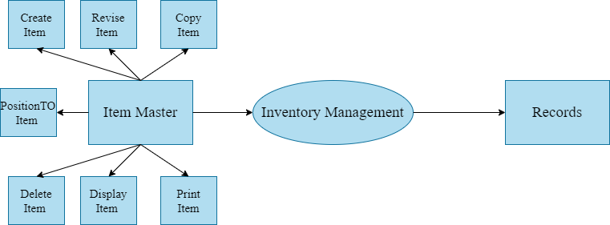

Level 3:
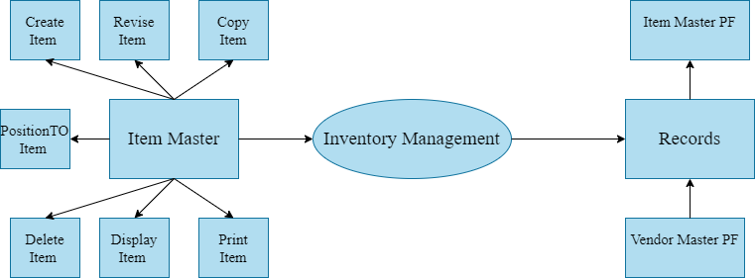

Data Flow Diagram for Customer Master
Level 1:

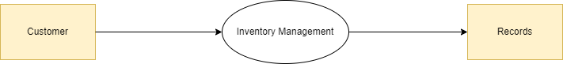

Level2:

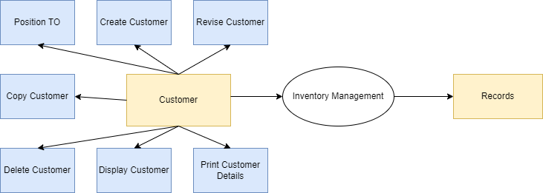

Level 3

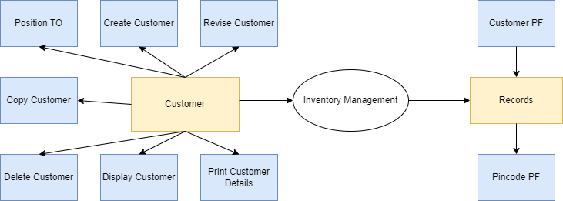

Data Flow Diagram for Customer Master

Level 1:

Level 2:

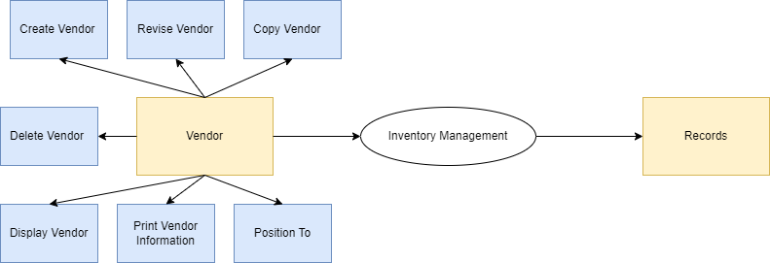

Level 3:

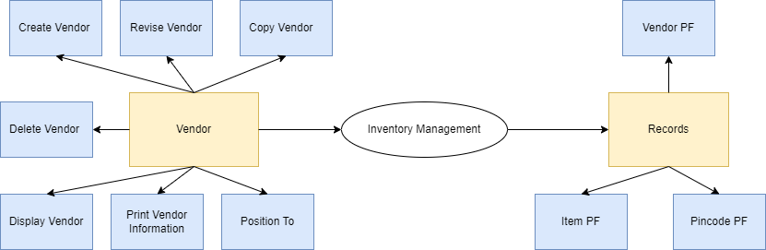

Screen Designing
Screens for Item Master
- Item Master Maintenance Screen: This screen is used to Create, Revise, Copy, Delete, Display, Print & Search the Item.
 | 12345678901234567890123456789012345678901234567890123456789012345678901234567890
1  2  3  4  5  6  7  8  9  10  11  12  13  14  15  16  17  18  19  20  21  22  23  24 | PROGRAM NAME PROGRAMMERS.IO WSID DATE  SYSTEM NAME Item Master Maintenance USER ID TIME  Select action and press Enter. 1= Create 2=Revise 3=Copy 4=Delete  5=Display 6=Print 8=Position To  Act Item Number Description Status  ___ _________________+  ___ OOOOOOOOOOOOOO OOOOOOOOOOOOOOOOOOOOOOOOOOO OOOOOOOO  ___ OOOOOOOOOOOOOO OOOOOOOOOOOOOOOOOOOOOOOOOOO OOOOOOOO  ___ OOOOOOOOOOOOOO OOOOOOOOOOOOOOOOOOOOOOOOOOO OOOOOOOO  ___ OOOOOOOOOOOOOO OOOOOOOOOOOOOOOOOOOOOOOOOOO OOOOOOOO  ___ OOOOOOOOOOOOOO OOOOOOOOOOOOOOOOOOOOOOOOOOO OOOOOOOO  ___ OOOOOOOOOOOOOO OOOOOOOOOOOOOOOOOOOOOOOOOOO OOOOOOOO  ___ OOOOOOOOOOOOOO OOOOOOOOOOOOOOOOOOOOOOOOOOO OOOOOOOO  ___ OOOOOOOOOOOOOO OOOOOOOOOOOOOOOOOOOOOOOOOOO OOOOOOOO  ___ OOOOOOOOOOOOOO OOOOOOOOOOOOOOOOOOOOOOOOOOO OOOOOOOO  ___ OOOOOOOOOOOOOO OOOOOOOOOOOOOOOOOOOOOOOOOOO OOOOOOOO  ___ OOOOOOOOOOOOOO OOOOOOOOOOOOOOOOOOOOOOOOOOO OOOOOOOO  ___ OOOOOOOOOOOOOO OOOOOOOOOOOOOOOOOOOOOOOOOOO OOOOOOOO  F3=Exit F4=Prompt F5=Refresh  OOOOOOOOOOOOOOOOOOOOOOOOOOOOOOOOOOOOOOOOOOOOOOOOOO

Validations:
- Validations on Invalid Input
- F4 works only in front of ‘+’ field

- Item Master Create Screen: This screen is used to add the new item to the inventory system.
 | 12345678901234567890123456789012345678901234567890123456789012345678901234567890
1  2  3  4  5  6  7  8  9  10  11  12  13  14  15  16  17  18  19  20  21  22  23  24 | PROGRAM NAME PROGRAMMERS.IO WSID DATE  ADD Add Item Screen in Item Master USER ID TIME  Item Number: BBBBBBBBBBBBBBB  Item Description: BBBBBBBBBBBBBBBBBBBBBBBBBBBBBBBBBBBBBBBBBBBBBBBBBBBBBB  Opening Balance: 99999999999 On Hand Quantity: 99999999999  Unit of Measure: BBBBBB On Order Quantity: 99999999999  Primary Vendor: 999999 Primary Vendor Item Number: BBBBBBBBBBBBBBB  Alternate Vendor: 999999 Alternate Vendor Item Number: BBBBBBBBBBBBBBB  Minimum Balance: 99999999999  Standard Cost Per Unit: 99999999999.99 Actual Cost Per Unit: 999999999999.99  F3=Exit F5=Refresh F6=Accept  OOOOOOOOOOOOOOOOOOOOOOOOOOOOOOOOOOOOOOOOOOOOOOOOOO

Validations:
- Item Number, Description, Unit of Measure, Primary Vendor Item Number, Alternate Vendor Item Number cannot be blank.
- Item Number must be unique.
- Opening Balance, On Hand Quantity, On Order Quantity, Primary Vendor, Alternate Vendor, Standard Cost and Actual Cost cannot be zero.
- Standard Cost always be greater than Actual Cost.

- Item Master Revise Screen: This screen is used to edit the details of the Item.
 | 12345678901234567890123456789012345678901234567890123456789012345678901234567890
1  2  3  4  5  6  7  8  9  10  11  12  13  14  15  16  17  18  19  20  21  22  23  24 | PROGRAM NAME PROGRAMMERS.IO WSID DATE  Revise Edit Item Screen of Item Master USER ID TIME  Item Number: OOOOOOOOOOOOOOO  Item Description: BBBBBBBBBBBBBBBBBBBBBBBBBBBBBBBBBBBBBBBBBBBBBBBBBBBBBB  Opening Balance: 99999999999 On Hand Quantity: 99999999999  Unit of Measure: BBBBBB On Order Quantity: 99999999999  Primary Vendor: 999999 Primary Vendor Item Number: BBBBBBBBBBBBBBB  Alternate Vendor: 999999 Alternate Vendor Item Number: BBBBBBBBBBBBBBB  Minimum Balance: 99999999999  Standard Cost Per Unit: 99999999999.99 Actual Cost Per Unit: 999999999999.99  F3=Exit F5=Refresh F6=Accept  OOOOOOOOOOOOOOOOOOOOOOOOOOOOOOOOOOOOOOOOOOOOOOOOOO
Validations:
- Item Description, Unit of Measure, Primary Vendor Item Number, Alternate Vendor Item Number cannot be blank.
- Opening Balance, On Hand Quantity, On Order Quantity, Primary Vendor, Alternate Vendor, Standard Cost and Actual Cost cannot be zero.
- Standard Cost always be greater than Actual Cost.
- Item Master Copy Screen: This screen is used to copy the item details.
 | 12345678901234567890123456789012345678901234567890123456789012345678901234567890
1  2  3  4  5  6  7  8  9  10  11  12  13  14  15  16  17  18  19  20  21  22  23  24 | PROGRAM NAME PROGRAMMERS.IO WSID DATE  COPY Copy Item Screen of Item Master USER ID TIME  Item Number: BBBBBBBBBBBBBBB  Item Description: BBBBBBBBBBBBBBBBBBBBBBBBBBBBBBBBBBBBBBBBBBBBBBBBBBBBBB  Opening Balance: 99999999999 On Hand Quantity: 99999999999  Unit of Measure: BBBBBB On Order Quantity: 99999999999  Primary Vendor: 999999 Primary Vendor Item Number: BBBBBBBBBBBBBBB  Alternate Vendor: 999999 Alternate Vendor Item Number: BBBBBBBBBBBBBBB  Minimum Balance: 99999999999  Standard Cost Per Unit: 99999999999.99 Actual Cost Per Unit: 999999999999.99  F3=Exit F5=Refresh F6=Accept  OOOOOOOOOOOOOOOOOOOOOOOOOOOOOOOOOOOOOOOOOOOOOOOOOO

Validations:
- Item Number, Description, Unit of Measure, Primary Vendor Item Number, Alternate Vendor Item Number cannot be blank.
- Item Number must be unique.
- Opening Balance, On Hand Quantity, On Order Quantity, Primary Vendor, Alternate Vendor, Standard Cost and Actual Cost cannot be zero.
- Standard Cost always be greater than Actual Cost.

- Item Master Delete Screen: This screen is used to delete the item.
 | 12345678901234567890123456789012345678901234567890123456789012345678901234567890
1  2  3  4  5  6  7  8  9  10  11  12  13  14  15  16  17  18  19  20  21  22  23  24 | PROGRAM NAME PROGRAMMERS.IO WSID DATE  Delete Item Master Maintenance USER ID TIME  Press Enter to confirm your choice for Delete.  Press F12=Cancel to return to change your choice.  Item Number Description  OOOOOOOOOOOOOO OOOOOOOOOOOOOOOOOOOOOOOOOOO  OOOOOOOOOOOOOO OOOOOOOOOOOOOOOOOOOOOOOOOOO  OOOOOOOOOOOOOO OOOOOOOOOOOOOOOOOOOOOOOOOOO  OOOOOOOOOOOOOO OOOOOOOOOOOOOOOOOOOOOOOOOOO  OOOOOOOOOOOOOO OOOOOOOOOOOOOOOOOOOOOOOOOOO  OOOOOOOOOOOOOO OOOOOOOOOOOOOOOOOOOOOOOOOOO  OOOOOOOOOOOOOO OOOOOOOOOOOOOOOOOOOOOOOOOOO  OOOOOOOOOOOOOO OOOOOOOOOOOOOOOOOOOOOOOOOOO  OOOOOOOOOOOOOO OOOOOOOOOOOOOOOOOOOOOOOOOOO  OOOOOOOOOOOOOO OOOOOOOOOOOOOOOOOOOOOOOOOOO  OOOOOOOOOOOOOO OOOOOOOOOOOOOOOOOOOOOOOOOOO  OOOOOOOOOOOOOO OOOOOOOOOOOOOOOOOOOOOOOOOOO  F12=Cancel  OOOOOOOOOOOOOOOOOOOOOOOOOOOOOOOOOOOOOOOOOOOOOOOOOO

Validations:
- Using Enter we can delete the selected item numbers.
- Using F12 we can abort the delete process.
- Item Master Display Screen: This screen is used to view the details of the item.
 | 12345678901234567890123456789012345678901234567890123456789012345678901234567890
1  2  3  4  5  6  7  8  9  10  11  12  13  14  15  16  17  18  19  20  21  22  23  24 | PROGRAM NAME PROGRAMMERS.IO WSID DATE  Display Display Screen of Item Master USER ID TIME  Item Number: BBBBBBBBBBBBBBB  Item Description: BBBBBBBBBBBBBBBBBBBBBBBBBBBBBBBBBBBBBBBBBBBBBBBBBBBBBB  Opening Balance: 99999999999 On Hand Quantity: 99999999999  Unit of Measure: BBBBBB On Order Quantity: 99999999999  Primary Vendor: 999999 Primary Vendor Item Number: BBBBBBBBBBBBBBB  Alternate Vendor: 999999 Alternate Vendor Item Number: BBBBBBBBBBBBBBB  Minimum Balance: 99999999999  Standard Cost Per Unit: 99999999999.99 Actual Cost Per Unit: 999999999999.99  F3=Exit  OOOOOOOOOOOOOOOOOOOOOOOOOOOOOOOOOOOOOOOOOOOOOOOOOO

Validations:
- All the fields are in protected.

- Item Master Prompt Window Screen: This window prompt open when F4 press on ‘+’ indicated field.
Press 1 for Select Item
Sel Item Number Description
Search Description: ___________________________________
____ OOOOOOOOOOOOOOO OOOOOOOOOOOOOOOOOOOOOOOOOOOOOOOO
____ OOOOOOOOOOOOOOO OOOOOOOOOOOOOOOOOOOOOOOOOOOOOOOO
____ OOOOOOOOOOOOOOO OOOOOOOOOOOOOOOOOOOOOOOOOOOOOOOO
____ OOOOOOOOOOOOOOO OOOOOOOOOOOOOOOOOOOOOOOOOOOOOOOO
____ OOOOOOOOOOOOOOO OOOOOOOOOOOOOOOOOOOOOOOOOOOOOOOO
____ OOOOOOOOOOOOOOO OOOOOOOOOOOOOOOOOOOOOOOOOOOOOOOO
____ OOOOOOOOOOOOOOO OOOOOOOOOOOOOOOOOOOOOOOOOOOOOOOO
____ OOOOOOOOOOOOOOO OOOOOOOOOOOOOOOOOOOOOOOOOOOOOOOO

F12=Cancel

OOOOOOOOOOOOOOOOOOOOOOOOOOOOOOOOOOOOOOOOOOOOOOOOOOOOOOOO

Validations:
- Only 1 for selection, other values give error.
- User can search based on item description.

- Item Master Print Option: By using 6 on any Item Number we can print its details, we can check the spool file.

- Item Master Position To: By using 8 on ‘+’ indicated field we can search the Item by Item Number.

Screens for Customer Master
- Customer Master Maintenance Screen: This screen is used to create, revise, copy, delete, display, print & search the customer.

 | 12345678901234567890123456789012345678901234567890123456789012345678901234567890
1  2  3  4  5  6  7  8  9  10  11  12  13  14  15  16  17  18  19  20  21  22  23  24 | PROGRAM NAME PROGRAMMERS.IO WSID DATE  SYSTEM NAME CUSTOMER Master Maintenance USER ID TIME  Select action and press Enter. 1= Create 2=Revise 3=Copy 4=Delete  5=Display 6=Print 8=Position To  Act Customer Customer Name Status  ___ _________ +  ___ 666666 OOOOOOOOOOOOOOOOOOOOOOOOOOO OOOOOOOO  ___ 666666 OOOOOOOOOOOOOOOOOOOOOOOOOOO OOOOOOOO  ___ 666666 OOOOOOOOOOOOOOOOOOOOOOOOOOO OOOOOOOO  ___ 666666 OOOOOOOOOOOOOOOOOOOOOOOOOOO OOOOOOOO  ___ 666666 OOOOOOOOOOOOOOOOOOOOOOOOOOO OOOOOOOO  ___ 666666 OOOOOOOOOOOOOOOOOOOOOOOOOOO OOOOOOOO  ___ 666666 OOOOOOOOOOOOOOOOOOOOOOOOOOO OOOOOOOO  ___ 666666 OOOOOOOOOOOOOOOOOOOOOOOOOOO OOOOOOOO  ___ 666666 OOOOOOOOOOOOOOOOOOOOOOOOOOO OOOOOOOO  ___ 666666 OOOOOOOOOOOOOOOOOOOOOOOOOOO OOOOOOOO  ___ 666666 OOOOOOOOOOOOOOOOOOOOOOOOOOO OOOOOOOO  ___ 666666 OOOOOOOOOOOOOOOOOOOOOOOOOOO OOOOOOOO  F3=Exit F4=Prompt F5=Refresh  OOOOOOOOOOOOOOOOOOOOOOOOOOOOOOOOOOOOOOOOOOOOOOOOOOOO

Validations:
- Validations on Invalid Input
- F4 works only in front of ‘+’ field

- Customer Master Create Screen: This screen is used to add the new customer to the inventory system.
 | 12345678901234567890123456789012345678901234567890123456789012345678901234567890
1  2  3  4  5  6  7  8  9  10  11  12  13  14  15  16  17  18  19  20  21  22  23  24 | PROGRAM NAME PROGRAMMERS.IO WSID DATE  Insert Insert Screen Customer Master USER ID TIME  Customer Number: 666666  Customer Name: BBBBBBBBBBBBBBBBBBBBBBBBBBBBBB  Address Line 1: BBBBBBBBBBBBBBBBBBBBBBBBBBBBBB  Address Line 2: BBBBBBBBBBBBBBBBBBBBBBBBBBBBBB (Optional)  Address Line 3: BBBBBBBBBBBBBBBBBBBBBBBBBBBBBB (Optional)  State: OOOOOOOOOOOOOOOOOOOOOOOOOOOO Postal Code: BBBBBB (F4=Prompt)  Country: OOOOOOOOOOOOOOOOOOOO Telephone NO: OOO BBBBBBBBBBBBBBBB  Email:BBBBBBBBBBBBBBBBBBBBBBBBBBBBBBBBBBBBBBBBBBBBBBBBBBBBBBBBBBBBBBBBB  Credit Limit: 999999999999999.99 Current O/S Amt: 9999999999999.99  F3=Exit F5=Refresh F6=Accept  OOOOOOOOOOOOOOOOOOOOOOOOOOOOOOOOOOOOOOOOOOOOOOOOOOOOOOO
Validations:
- Customer Number is auto generated.
- Customer Name, Address Line 1 cannot be blank.
- Customer Name takes alphabets & space only.
- Customer Address Line 2& 3 are optional.
- State, Country & Tele-code are auto filled based on Postal Code.
- Postal Code filed is protected, we can use f4 here.
- Email & Telephone Number validation based on standards, cannot register with already registered values.
- Credit Limit & Current O/S Amt cannot be blanks.
- F3 for exit, F5 for refresh and F6 to submit details
- Customer Master Revise Screen: This screen is used to revise the customer to the inventory system.
 | 12345678901234567890123456789012345678901234567890123456789012345678901234567890
1  2  3  4  5  6  7  8  9  10  11  12  13  14  15  16  17  18  19  20  21  22  23  24 | PROGRAM NAME PROGRAMMERS.IO WSID DATE  Revise Customer Master Revise Screen USER ID TIME  Customer Number: 666666  Customer Name: BBBBBBBBBBBBBBBBBBBBBBBBBBBBBB  Address Line 1: BBBBBBBBBBBBBBBBBBBBBBBBBBBBBB  Address Line 2: BBBBBBBBBBBBBBBBBBBBBBBBBBBBBB (Optional)  Address Line 3: BBBBBBBBBBBBBBBBBBBBBBBBBBBBBB (Optional)  State: OOOOOOOOOOOOOOOOOOOOOOOOOOOO Postal Code: BBBBBB (F4=Prompt)  Country: OOOOOOOOOOOOOOOOOOOO Telephone NO: OOO BBBBBBBBBBBBBBBB  Email:BBBBBBBBBBBBBBBBBBBBBBBBBBBBBBBBBBBBBBBBBBBBBBBBBBBBBBBBBBBBBBBBB  Credit Limit: 999999999999999.99 Current O/S Amt: 9999999999999.99  F3=Exit F5=Refresh F6=Accept  OOOOOOOOOOOOOOOOOOOOOOOOOOOOOOOOOOOOOOOOOOOOOOOOOOOOOOO

Validations:
- At least one field must revise to submit.
- All fields validations are same as customer insert screen.

- Customer Master Copy Screen: This screen is used to create a new customer by using copy option.
 | 12345678901234567890123456789012345678901234567890123456789012345678901234567890
1  2  3  4  5  6  7  8  9  10  11  12  13  14  15  16  17  18  19  20  21  22  23  24 | PROGRAM NAME PROGRAMMERS.IO WSID DATE  Copy Customer Master Copy Screen USER ID TIME  Customer Number: 666666  Customer Name: BBBBBBBBBBBBBBBBBBBBBBBBBBBBBB  Address Line 1: BBBBBBBBBBBBBBBBBBBBBBBBBBBBBB  Address Line 2: BBBBBBBBBBBBBBBBBBBBBBBBBBBBBB (Optional)  Address Line 3: BBBBBBBBBBBBBBBBBBBBBBBBBBBBBB (Optional)  State: OOOOOOOOOOOOOOOOOOOOOOOOOOOO Postal Code: BBBBBB (F4=Prompt)  Country: OOOOOOOOOOOOOOOOOOOO Telephone NO: OOO BBBBBBBBBBBBBBBB  Email:BBBBBBBBBBBBBBBBBBBBBBBBBBBBBBBBBBBBBBBBBBBBBBBBBBBBBBBBBBBBBBBBB  Credit Limit: 999999999999999.99 Current O/S Amt: 9999999999999.99  F3=Exit F5=Refresh F6=Accept  OOOOOOOOOOOOOOOOOOOOOOOOOOOOOOOOOOOOOOOOOOOOOOOOOOOOOOO

Validations:
- Customer Number auto generated, and all fields fill with the same values where we use 3 option.
- Telephone number & Email have to change, can not register with already registered values.
- All fields validations are same as customer insert screen.

- Customer Master Delete Screen: This screen is used to delete customer from inventory management system.
 | 12345678901234567890123456789012345678901234567890123456789012345678901234567890
1  2  3  4  5  6  7  8  9  10  11  12  13  14  15  16  17  18  19  20  21  22  23  24 | PROGRAM NAME PROGRAMMERS.IO WSID DATE  Delete Customer Master Maintenance USER ID TIME  Press Enter to confirm your choice for Delete.  Press F12=Cancel to return to change your choice.  Customer Number Customer Name  OOOOOO OOOOOOOOOOOOOOOOOOOOOOOOOOO  OOOOOO OOOOOOOOOOOOOOOOOOOOOOOOOOO  OOOOOO OOOOOOOOOOOOOOOOOOOOOOOOOOO  OOOOOO OOOOOOOOOOOOOOOOOOOOOOOOOOO  OOOOOO OOOOOOOOOOOOOOOOOOOOOOOOOOO  OOOOOO OOOOOOOOOOOOOOOOOOOOOOOOOOO  OOOOOO OOOOOOOOOOOOOOOOOOOOOOOOOOO  OOOOOO OOOOOOOOOOOOOOOOOOOOOOOOOOO  OOOOOO OOOOOOOOOOOOOOOOOOOOOOOOOOO  OOOOOO OOOOOOOOOOOOOOOOOOOOOOOOOOO  OOOOOO OOOOOOOOOOOOOOOOOOOOOOOOOOO  OOOOOO OOOOOOOOOOOOOOOOOOOOOOOOOOO  F12=Cancel  OOOOOOOOOOOOOOOOOOOOOOOOOOOOOOOOOOOOOOOOOOOOOOOOOO

Validations:
- Using Enter we can delete the selected customers.
- Using F12 we can abort the delete process.

- Customer Master Display Screen: This screen is used to display customer details.

 | 12345678901234567890123456789012345678901234567890123456789012345678901234567890
1  2  3  4  5  6  7  8  9  10  11  12  13  14  15  16  17  18  19  20  21  22  23  24 | PROGRAM NAME PROGRAMMERS.IO WSID DATE  Display Customer Master Display Screen USER ID TIME  Customer Number: 666666  Customer Name: BBBBBBBBBBBBBBBBBBBBBBBBBBBBBB  Address Line 1: BBBBBBBBBBBBBBBBBBBBBBBBBBBBBB  Address Line 2: BBBBBBBBBBBBBBBBBBBBBBBBBBBBBB  Address Line 3: BBBBBBBBBBBBBBBBBBBBBBBBBBBBBB  State: OOOOOOOOOOOOOOOOOOOOOOOOOOOO Postal Code: BBBBBB  Country: OOOOOOOOOOOOOOOOOOOO Telephone NO: OOO BBBBBBBBBBBBBBBB  Email:BBBBBBBBBBBBBBBBBBBBBBBBBBBBBBBBBBBBBBBBBBBBBBBBBBBBBBBBBBBBBBBBB  Credit Limit: 999999999999999.99 Current O/S Amt: 9999999999999.99  F3=Exit  OOOOOOOOOOOOOOOOOOOOOOOOOOOOOOOOOOOOOOOOOOOOOOOOOOOOOOO

Validations:
- All the fields are in protected.

- Customer Master Prompt Window Screen: This window prompt open when F4 press on ‘+’ indicated field.
Press 1 for Select
Sel Customer Number Description
Search Name: ___________________________________
__ OOOOOO OOOOOOOOOOOOOOOOOOOOOOOOOOOOOOOO
__ OOOOOO OOOOOOOOOOOOOOOOOOOOOOOOOOOOOOOO
__ OOOOOO OOOOOOOOOOOOOOOOOOOOOOOOOOOOOOOO
__ OOOOOO OOOOOOOOOOOOOOOOOOOOOOOOOOOOOOOO
__ OOOOOO OOOOOOOOOOOOOOOOOOOOOOOOOOOOOOOO
__ OOOOOO OOOOOOOOOOOOOOOOOOOOOOOOOOOOOOOO
__ OOOOOO OOOOOOOOOOOOOOOOOOOOOOOOOOOOOOOO
__ OOOOOO OOOOOOOOOOOOOOOOOOOOOOOOOOOOOOOO

F12=Cancel

OOOOOOOOOOOOOOOOOOOOOOOOOOOOOOOOOOOOOOOOOOOOOOOOOOOOOOO

Validations:
- Only 1 for selection, other values give error.
- User can search based on customer name.

- Customer Master Print Option: By using 6 on any Customer Number we can print its details, we can check the spool file.

- Customer Master Position To: By using 8 on ‘+’ indicated field we can search the Customer-by-Customer Number.

Screens for Vender Master
- Vendor Master Maintenance Screen: This screen is used to create, revise, copy, delete, display, print and search the vendor.
 | 12345678901234567890123456789012345678901234567890123456789012345678901234567890
1  2  3  4  5  6  7  8  9  10  11  12  13  14  15  16  17  18  19  20  21  22  23  24 | PROGRAM NAME PROGRAMMERS.IO WSID DATE  SYSTEM NAME Vendor Master Maintenance USER ID TIME  Select action and press Enter. 1= Create 2=Revise 3=Copy 4=Delete  5=Display 6=Print 8=Position To  Act Vendor Name Status  ___ _________ +  ___ 666666 OOOOOOOOOOOOOOOOOOOOOOOOOOO OOOOOOOO  ___ 666666 OOOOOOOOOOOOOOOOOOOOOOOOOOO OOOOOOOO  ___ 666666 OOOOOOOOOOOOOOOOOOOOOOOOOOO OOOOOOOO  ___ 666666 OOOOOOOOOOOOOOOOOOOOOOOOOOO OOOOOOOO  ___ 666666 OOOOOOOOOOOOOOOOOOOOOOOOOOO OOOOOOOO  ___ 666666 OOOOOOOOOOOOOOOOOOOOOOOOOOO OOOOOOOO  ___ 666666 OOOOOOOOOOOOOOOOOOOOOOOOOOO OOOOOOOO  ___ 666666 OOOOOOOOOOOOOOOOOOOOOOOOOOO OOOOOOOO  ___ 666666 OOOOOOOOOOOOOOOOOOOOOOOOOOO OOOOOOOO  ___ 666666 OOOOOOOOOOOOOOOOOOOOOOOOOOO OOOOOOOO  ___ 666666 OOOOOOOOOOOOOOOOOOOOOOOOOOO OOOOOOOO  ___ 666666 OOOOOOOOOOOOOOOOOOOOOOOOOOO OOOOOOOO  F3=Exit F4=Prompt F5=Refresh  OOOOOOOOOOOOOOOOOOOOOOOOOOOOOOOOOOOOOOOOOOOOOOOOOOOO

Validations:
- Validations on Invalid Input
- F4 works only in front of ‘+’ field

- Vendor Master Create Screen: This screen is used to add the new vendor to the inventory system.
 | 12345678901234567890123456789012345678901234567890123456789012345678901234567890
1  2  3  4  5  6  7  8  9  10  11  12  13  14  15  16  17  18  19  20  21  22  23  24 | PROGRAM NAME PROGRAMMERS.IO WSID DATE  Insert Insert Screen Vendor Master USER ID TIME  Vendor Number: 666666  Vendor Name: BBBBBBBBBBBBBBBBBBBBBBBBBBBBBB  Address Line 1: BBBBBBBBBBBBBBBBBBBBBBBBBBBBBB  Address Line 2: BBBBBBBBBBBBBBBBBBBBBBBBBBBBBB (Optional)  Address Line 3: BBBBBBBBBBBBBBBBBBBBBBBBBBBBBB (Optional)  State: OOOOOOOOOOOOOOOOOOOOOOOOOOOO Postal Code: BBBBBB (F4=Prompt)  Country: OOOOOOOOOOOOOOOOOOOO Telephone NO: OOO BBBBBBBBBBBBBBBB  Email:BBBBBBBBBBBBBBBBBBBBBBBBBBBBBBBBBBBBBBBBBBBBBBBBBBBBBBBBBBBBBBBBB  Credit Limit: 999999999999999.99 Current O/S Amt: 9999999999999.99  F3=Exit F5=Refresh F6=Accept  OOOOOOOOOOOOOOOOOOOOOOOOOOOOOOOOOOOOOOOOOOOOOOOOOOOOOOO
Validations:
- Vendor Number is auto generated.
- Vendor Name, Address Line 1 cannot be blank.
- Vendor Name takes alphabets & space only.
- Vendor Address Line 2& 3 are optional.
- State, Country & Tele-code are auto filled based on Postal-Code.
- Postal-Code filed is protected, we can use f4 here.
- Email & Telephone Number validation based on standards, cannot register with already registered values.
- Credit Limit & Current O/S Amt cannot be blanks.
- F3 for exit, F5 for refresh and F6 to submit details
- Vendor Master Revise Screen: This screen is used to revise the details of the vendor.
 | 12345678901234567890123456789012345678901234567890123456789012345678901234567890
1  2  3  4  5  6  7  8  9  10  11  12  13  14  15  16  17  18  19  20  21  22  23  24 | PROGRAM NAME PROGRAMMERS.IO WSID DATE  Revise Vendor Master Revise Screen USER ID TIME  Vendor Number: 666666  Vendor Name: BBBBBBBBBBBBBBBBBBBBBBBBBBBBBB  Address Line 1: BBBBBBBBBBBBBBBBBBBBBBBBBBBBBB  Address Line 2: BBBBBBBBBBBBBBBBBBBBBBBBBBBBBB (Optional)  Address Line 3: BBBBBBBBBBBBBBBBBBBBBBBBBBBBBB (Optional)  State: OOOOOOOOOOOOOOOOOOOOOOOOOOOO Postal Code: BBBBBB (F4=Prompt)  Country: OOOOOOOOOOOOOOOOOOOO Telephone NO: OOO BBBBBBBBBBBBBBBB  Email:BBBBBBBBBBBBBBBBBBBBBBBBBBBBBBBBBBBBBBBBBBBBBBBBBBBBBBBBBBBBBBBBB  Credit Limit: 999999999999999.99 Current O/S Amt: 9999999999999.99  F3=Exit F5=Refresh F6=Accept  OOOOOOOOOOOOOOOOOOOOOOOOOOOOOOOOOOOOOOOOOOOOOOOOOOOOOOO

Validations:
- At least one field must revise to submit.
- All fields validations are same as vendor insert screen.

- Vendor Master Copy Screen: This screen is used to create a new vendor by using copy option.
 | 12345678901234567890123456789012345678901234567890123456789012345678901234567890
1  2  3  4  5  6  7  8  9  10  11  12  13  14  15  16  17  18  19  20  21  22  23  24 | PROGRAM NAME PROGRAMMERS.IO WSID DATE  Copy Vendor Master Copy Screen USER ID TIME  Vendor Number: 666666  Vendor Name: BBBBBBBBBBBBBBBBBBBBBBBBBBBBBB  Address Line 1: BBBBBBBBBBBBBBBBBBBBBBBBBBBBBB  Address Line 2: BBBBBBBBBBBBBBBBBBBBBBBBBBBBBB (Optional)  Address Line 3: BBBBBBBBBBBBBBBBBBBBBBBBBBBBBB (Optional)  State: OOOOOOOOOOOOOOOOOOOOOOOOOOOO Postal Code: BBBBBB (F4=Prompt)  Country: OOOOOOOOOOOOOOOOOOOO Telephone NO: OOO BBBBBBBBBBBBBBBB  Email:BBBBBBBBBBBBBBBBBBBBBBBBBBBBBBBBBBBBBBBBBBBBBBBBBBBBBBBBBBBBBBBBB  Credit Limit: 999999999999999.99 Current O/S Amt: 9999999999999.99  F3=Exit F5=Refresh F6=Accept  OOOOOOOOOOOOOOOOOOOOOOOOOOOOOOOOOOOOOOOOOOOOOOOOOOOOOOO

Validations:
- Vendor Number auto generated, and all fields fill with the same values where we use 3 option.
- Telephone Number & Email have to change, cannot register with already registered values.
- All fields validations are same as vendor insert screen.

- Vendor Master Delete Screen: This screen is used to delete vendor from inventory management system.
 | 12345678901234567890123456789012345678901234567890123456789012345678901234567890
1  2  3  4  5  6  7  8  9  10  11  12  13  14  15  16  17  18  19  20  21  22  23  24 | PROGRAM NAME PROGRAMMERS.IO WSID DATE  Delete Vendor Master Maintenance USER ID TIME  Press Enter to confirm your choice for Delete.  Press F12=Cancel to return to change your choice.  Vendor Number Vendor Name  OOOOOO OOOOOOOOOOOOOOOOOOOOOOOOOOO  OOOOOO OOOOOOOOOOOOOOOOOOOOOOOOOOO  OOOOOO OOOOOOOOOOOOOOOOOOOOOOOOOOO  OOOOOO OOOOOOOOOOOOOOOOOOOOOOOOOOO  OOOOOO OOOOOOOOOOOOOOOOOOOOOOOOOOO  OOOOOO OOOOOOOOOOOOOOOOOOOOOOOOOOO  OOOOOO OOOOOOOOOOOOOOOOOOOOOOOOOOO  OOOOOO OOOOOOOOOOOOOOOOOOOOOOOOOOO  OOOOOO OOOOOOOOOOOOOOOOOOOOOOOOOOO  OOOOOO OOOOOOOOOOOOOOOOOOOOOOOOOOO  OOOOOO OOOOOOOOOOOOOOOOOOOOOOOOOOO  OOOOOO OOOOOOOOOOOOOOOOOOOOOOOOOOO  F12=Cancel  OOOOOOOOOOOOOOOOOOOOOOOOOOOOOOOOOOOOOOOOOOOOOOOOOO

Validations:
- Using Enter we can delete the selected vendors.
- Using F12 we can abort the delete process.

- Vendor Master Display Screen: This screen is used to display vendor details.

 | 12345678901234567890123456789012345678901234567890123456789012345678901234567890
1  2  3  4  5  6  7  8  9  10  11  12  13  14  15  16  17  18  19  20  21  22  23  24 | PROGRAM NAME PROGRAMMERS.IO WSID DATE  Display Vendor Master Display Screen USER ID TIME  Vendor Number: 666666  Vendor Name: BBBBBBBBBBBBBBBBBBBBBBBBBBBBBB  Address Line 1: BBBBBBBBBBBBBBBBBBBBBBBBBBBBBB  Address Line 2: BBBBBBBBBBBBBBBBBBBBBBBBBBBBBB  Address Line 3: BBBBBBBBBBBBBBBBBBBBBBBBBBBBBB  State: OOOOOOOOOOOOOOOOOOOOOOOOOOOO Postal Code: BBBBBB  Country: OOOOOOOOOOOOOOOOOOOO Telephone NO: OOO BBBBBBBBBBBBBBBB  Email:BBBBBBBBBBBBBBBBBBBBBBBBBBBBBBBBBBBBBBBBBBBBBBBBBBBBBBBBBBBBBBBBB  Credit Limit: 999999999999999.99 Current O/S Amt: 9999999999999.99  F3=Exit  OOOOOOOOOOOOOOOOOOOOOOOOOOOOOOOOOOOOOOOOOOOOOOOOOOOOOOO

Validations:
- All the fields are in protected.

- Vendor Master Prompt Window Screen: This window prompt open when F4 press on ‘+’ indicated field.
Press 1 for Select
Sel vendor Number Description
Search Name: ___________________________________
__ OOOOOO OOOOOOOOOOOOOOOOOOOOOOOOOOOOOOOO
__ OOOOOO OOOOOOOOOOOOOOOOOOOOOOOOOOOOOOOO
__ OOOOOO OOOOOOOOOOOOOOOOOOOOOOOOOOOOOOOO
__ OOOOOO OOOOOOOOOOOOOOOOOOOOOOOOOOOOOOOO
__ OOOOOO OOOOOOOOOOOOOOOOOOOOOOOOOOOOOOOO
__ OOOOOO OOOOOOOOOOOOOOOOOOOOOOOOOOOOOOOO
__ OOOOOO OOOOOOOOOOOOOOOOOOOOOOOOOOOOOOOO
__ OOOOOO OOOOOOOOOOOOOOOOOOOOOOOOOOOOOOOO

F12=Cancel

OOOOOOOOOOOOOOOOOOOOOOOOOOOOOOOOOOOOOOOOOOOOOOOOOOOOOOO

Validations:
- Only 1 for selection, other values give error.
- User can search based on Vendor Name.

- Vendor Master Print Option: By using 6 on any Vendor Number we can print its details, we can check the spool file.

- Vendor Master Position To: By using 8 on ‘+’ indicated field we can search the Vendor-by-Vendor Number.

